[Download Qt](https://www.qt.io/download-qt-installer-oss?hsCtaTracking=99d9dd4f-5681-48d2-b096-470725510d34%7C074ddad0-fdef-4e53-8aa8-5e8a876d6ab4)

Create an account to gain access to the installer.

Open the installer and enter your Login Credentials on the Welcome page, select NEXT

Check the Open Source Obligations Agreement, select NEXT

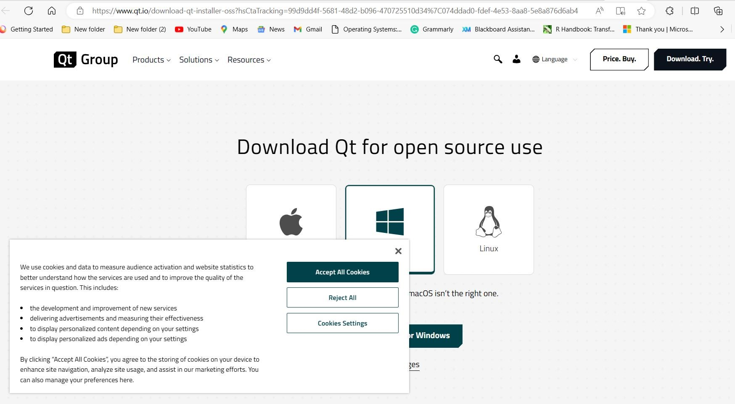

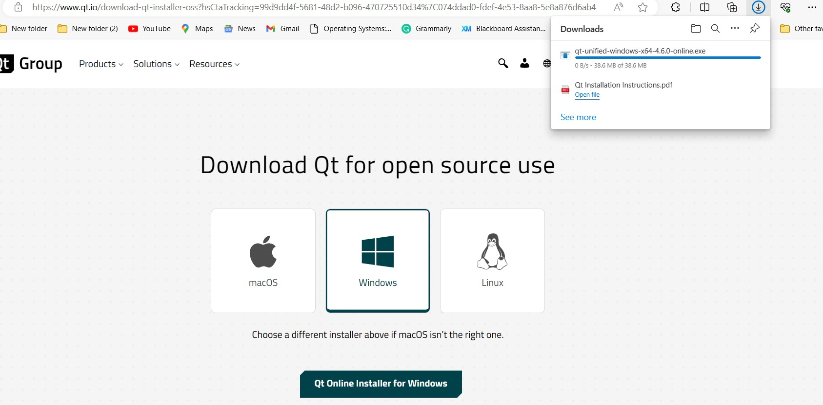

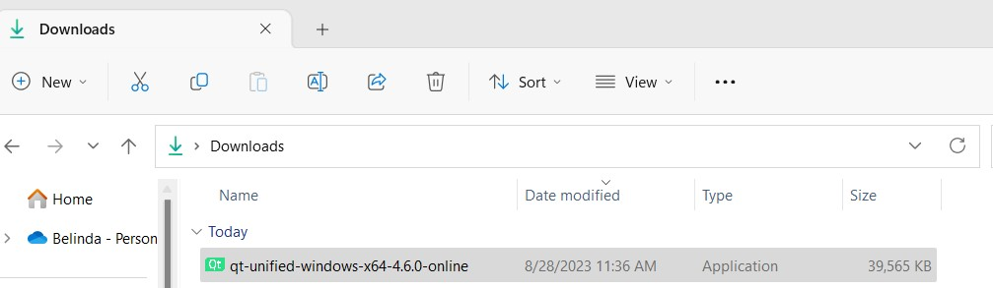

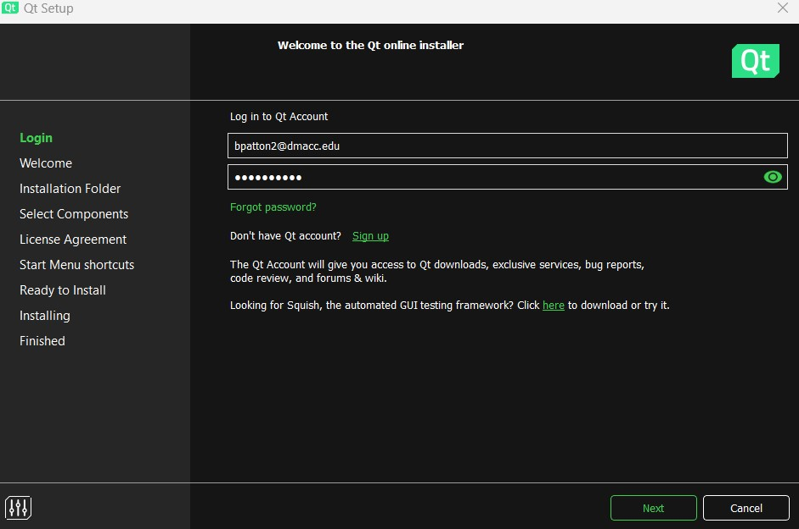

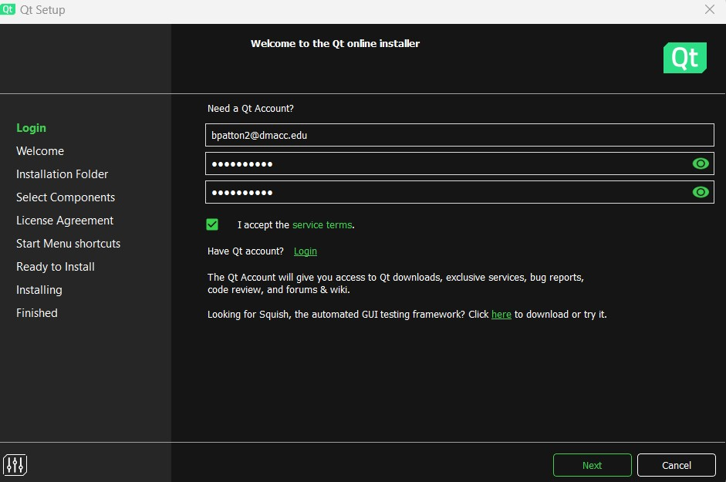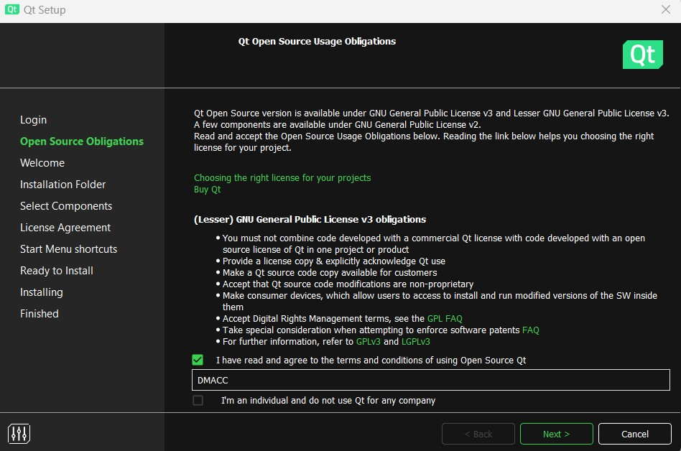

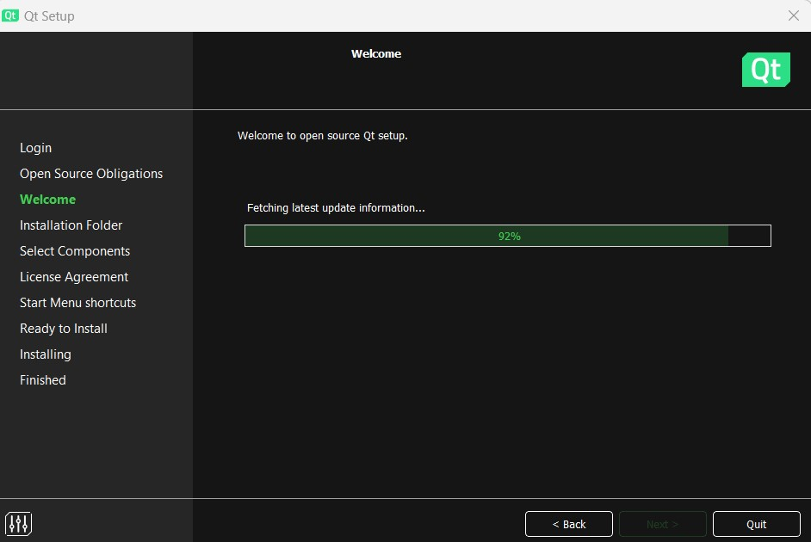

Select your Contribution choice, select NEXT

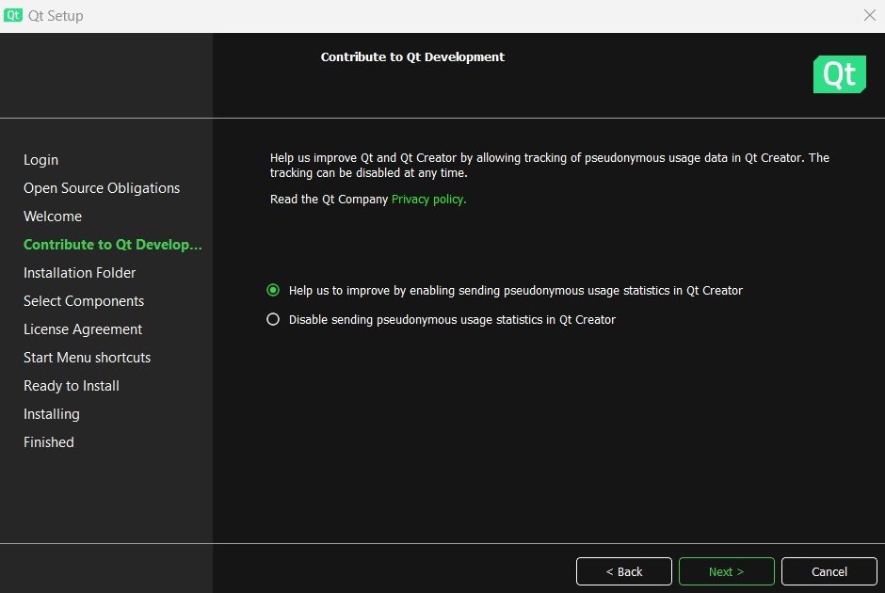

Confirm the Installation Folder and select Qt for desktop development, select NEXT

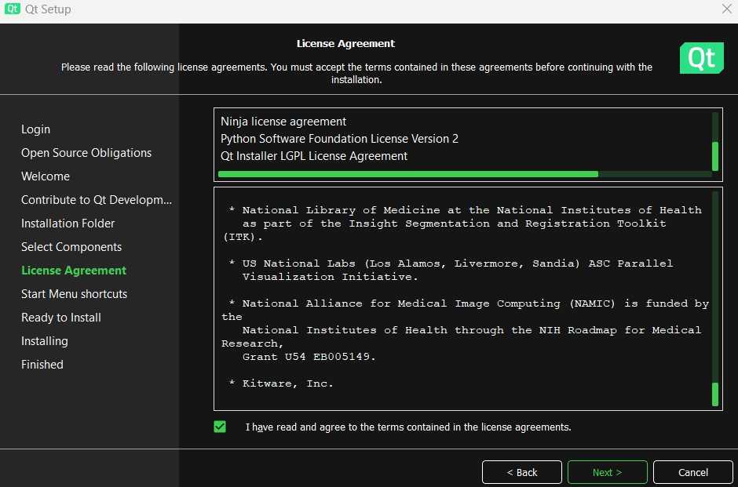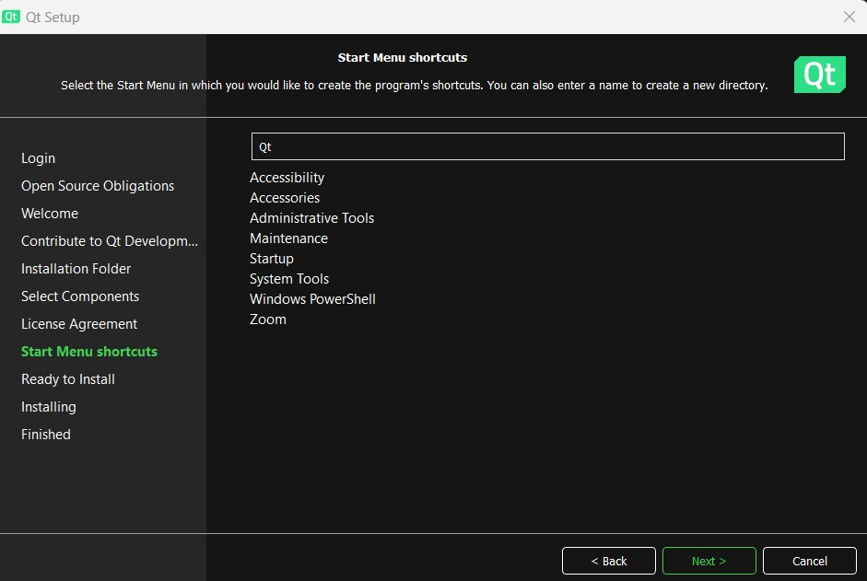

Select Finish. Now it’s time to test your installation!

Test your installation by selecting “Create Project”. Select “Application Qt”, “Qt Console Application”, “Choose”.

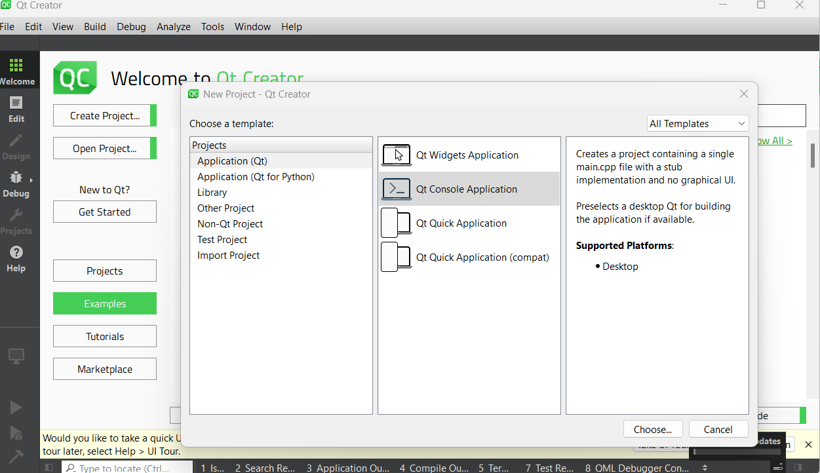

Select the location options and other settings below, select NEXT

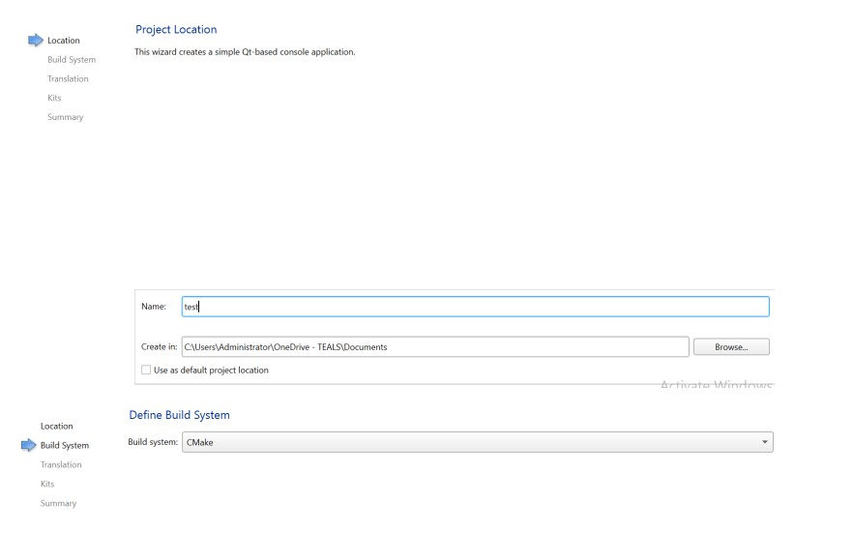

Your Debug and Run buttons should be green.

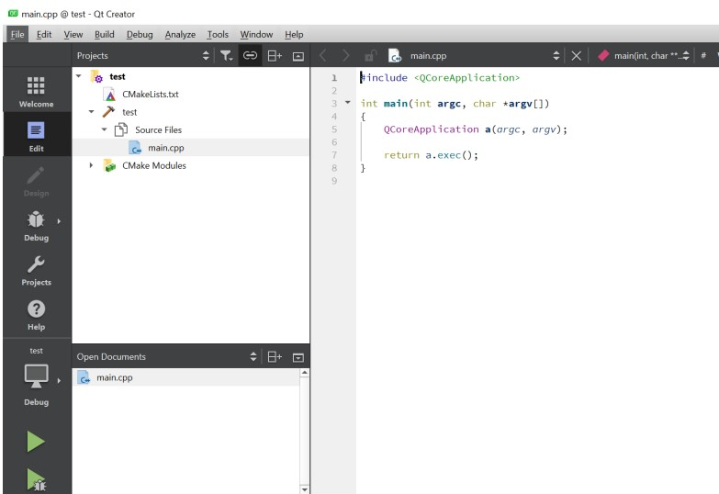

|  |  |
| --- | --- |
| Click Projects. Select the Project to Run in Terminal under “Active Projects”. Check the “Run in Terminal” checkbox to use the terminal for input and output | |
| statement. |  |

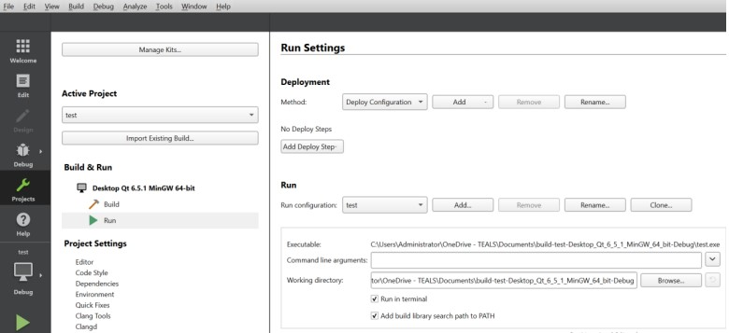

Click Edit to update the default code in main.cpp file

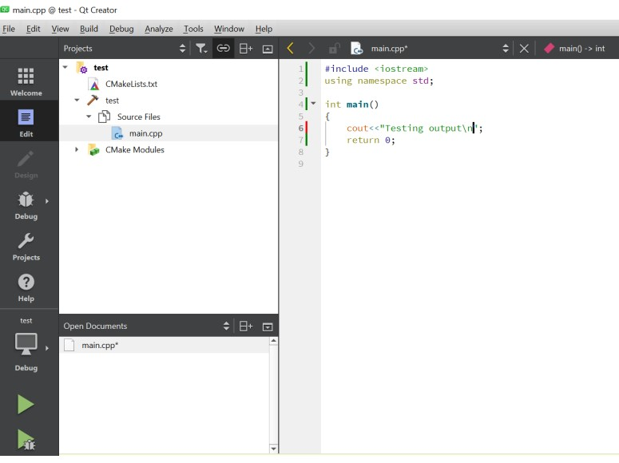

Click the RUN button to test your code display the results in a terminal window, SAVE ALL changes

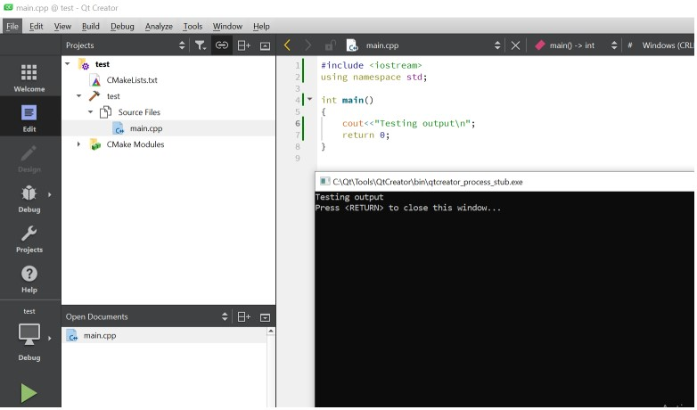

Email your instructor if you have questions